**Project Design Phase-I**

**Solution Architecture**

|  |  |
| --- | --- |
| Date | 22 October 2022 |
| Team ID | PNT2022TMID51213 |
| Project Name | AI-based discourse for Banking Industry |
| Maximum Marks | 4 Marks |

**Solution Architecture:**

* Scope, design, and integration are the three stages of a Watson Assistantbased chatbot project.
* The needs for the discussion and the current level of customer support for the use case are gathered during the scoping phase. They may possess a script, coded instructions, or other relics.
* You develop a system context diagram, a map of empathy, and persona definitions. After that, you extract the possible list of intents. Intents are the intentions or objectives that users convey in their input, such as responding to a question or carrying out a transaction. Intents are defined, and then the phrases that lead to those intents are evaluated.
* To define the intents and entities during the design phase, you must construct a Watson Assistant instance and use its builder tool. An object symbolises a class The dialogue flow is launched and unit tested at the conclusion of the design phase, and the web application or microservice that communicates with Watson Assistant is created during the integration phase.
* You add additional elements to support the business requirements, such as the IBM Watson Retrieve and Rank Service, ODM business rules, or IBM BPM process, after implementing the business logic to handle the conversation context.

**Solution Architecture Diagram:**

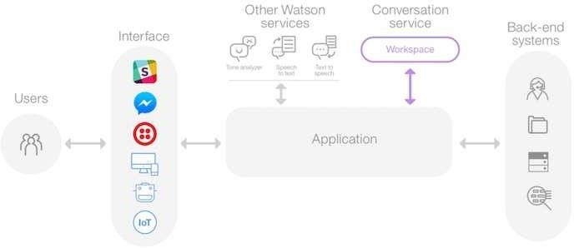

*Figure 1: Architecture and data flow of the chatbot application*